**International Project Management**

DIGITAL HEARING ASSISTANT

“Gamification and Educational Concepts”

**Prepared by:**

Makarand S. Thorat

Marietto Schuster

Maurice Chrisnach

Mhammed Amine Drif

Praveen Kumar Appari

Swaraj Rath

Varsha Venugopal

**Under the guidance of:**

Prof. Dr. Gerd Moeckel

**SRH Hochschule Heidelberg**

**Fakultät für Information, Medien und Design**

April-May 2019

**Table of Contents**

**Contents**

1. Project Description **5**

1.1 Purpose 5

1.2 Background 5

1.3 Duration and Location 5

1.4 Project Process 6

1.5 Target State and Target structure 6

**2. Team Roles & Responsibilities** **7**

3. MoSCoW Requirements **8**

3.1 Must Have 9

3.2 Should Have 9

3.3 Could Have 9

3.4 Nice to Have 9

**4. SWOT Analysis** **9**

4.1 Line Parameters in SWOT 10

4.2 S.W.O.T Chart 10

**5. Requirement Analysis** **12**

5.1 Functional Requirements 12

5.2 Technical Requirements 12

5.3 Operational Requirements 12

5.4 Development Requirements 12

6. Use Cases **13**

6.1 Usage Scenario 13

6.2 Process Workflow Model 13

6.3 Use Cases 14

6.4 Use Case Model 17

**7. Stakeholder Analysis** **18**

7.1 Internal Stakeholders 19

7.1.1 Product Owner 19

7.1.2 Development Team 19

7.2 External Stakeholders 20

7.2.1 Teachers 20

7.2.2 Therapists 20

7.2.3 Parents 20

7.2.4 Users 21

7.2.5 Implant Manufacturer 21

7.2.6 Other Potential Users 21

7.3 Influence and Impact of Stakeholders 21

**8. Project Methodology** **22**

8.1 Agile Methodology 22

8.2 Milestones 23

8.3 Project Plan 23

**9. Risk Analysis** **24**

9.1 Risk Management Plan 24

9.2 Risk Assessment Matrix 29

9.3 Risk Matrix Grid 30

**10. Gamification & Education Concept for the Digital Hearing Assistant** **30**

10.1 Gamification Aspect 30

10.2 Game-based learning 30

10.2.1 Education Aspect 31

10.2.2 Relation to Hearing Tests for Children 31

Play audiometry: 31

10.3 Gamification & Education in combination with “Digital Hearing Assistant App” 31

10.3.1 Game Functionalities Overview 32

10.3.2 Stages 32

10.3.3 Reward System 36

10.3.3.1 The Reward Gallery 36

10.3.3.2 Rewards with Educative Background 37

10.3.4 Tutorial Features 37

10.3.4.1 Introduction Tutorial 38

10.3.4.2 Continuous Tutorial 38

10.3.5 Data Collection 39

10.4 Game Editor 39

**11. Executive Summary** **40**

**12. References** **41**

**List of Figures**

Figure 1: Project Process model 6

Figure 2: SWOT Analysis Graph 11

Figure 3: Process Workflow Model 13

Figure 4: Use Case Model 17

Figure 5: Influence and impact of stakeholders 20

Figure 6: Gantt Chart 22

Figure 7: Project Plan 23

Figure 8: Risk Diagram 26

Figure 9: Risk Matrix Grid 31

Figure 10: Initiation Test 34

Figure 11: Sample Scene Stage 1 35

Figure 12: Quiz Sample 36

Figure 13: Correct Quiz Answer 36

Figure 14: Example Gallery 37

Figure 15: Different Image Stages 38

Figure 16: Owl Mascot 39

Figure 17: Editor Example 40

**List of Tables**

Table 1: Roles & Responsibilities 7

Table 2: Use Cases 14

Table 3: Risk Analysis and Mitigation 27

Table 4: Risk Assessment Matrix 30

## 1. Project Description

### 1.1 Purpose

The ultimate goal of the project is to develop a concept for an application dedicated to children between 4-6, who have just begun to hear using a cochlear implant and to help them hear and learn sounds of different activities, things, animals, etc. Additionally, increasing the sales of this device is crucial for the company selling the cochlea implants. This implant is used to replace the damaged inner ear, and to provide signals that the brain can use for recognizing sounds and voices.

The Gamification and Educational Concept department have to provide a concept of a Digital Hearing Assistant for kids between the age of 4-6 years. The Application, which will be available on any Tablet device, must be simple and fun to use for kids and in-turn help them learn. Parents, teachers and also audiologist can use the software and they can take action to create them one scene with different objects and sounds to teach the Kids. A Mascot will be available to help the children to use the application with funny and realistic animations, so they will not have any difficulty while using it.

### 1.2 Background

“Heidelberg Hearing” is a company, familiar with this neuroprosthetic device. They want to join the wave of digitization and boost the sales of the Cochlear implant. Therefore, they collaborate with “SRH University” to develop an application for kids, not able to read. This way they will learn how to handle the signal sent by the implant and start recognizing sounds again.

### 1.3 Duration and Location

Project start date: 01.06.2019

Project finish date: 01.12.2019

Duration of the Project: 6 Months

The project will take place in “Heidelberg,Germany”.

### 1.4 Project Process

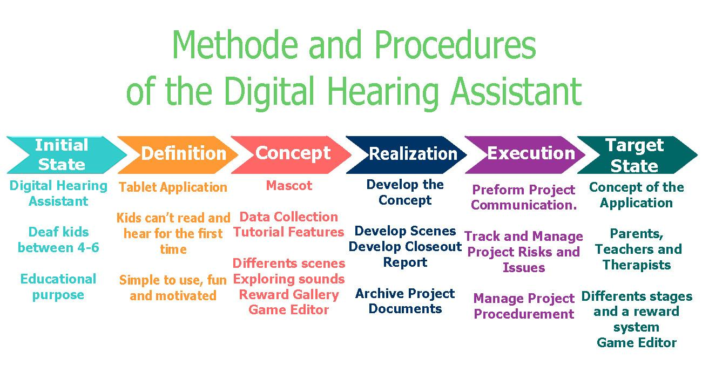

Figure 1: Project Process model

### 1.5 Target State and Target structure

**Higher Level Objectives:**

“Digital Hearing Assistant” for the deaf kids using the Cochlear Implant who can’t hear voices and can’t read, they have problem in the inner ear, the nerve which transfer signals to the brain is damaged.

**Result Objectives:**

Uncomplicated, fun and educational concept for an application dedicated to children which can be used by parents, therapists and teachers to evaluate the kids learning, and also to create scenes with an editor. Additionally, the application should provide a Mascot to help the kids if they have some difficulty with funny animations.

**Process Objectives:**

To achieve the final concept of the digital hearing assistant, the Gamification and educational concept department organized meetings to discuss about the Game and the different scenes of every stage, they also manage the project risks and issues to get on the target state the final conception .

**Personal Objectives:**

Some of the gamification and educational concept goals:

* Productivity and Creativity
* Practice
* Management of Time and Costs
* Responsibilities
* Knowledge of Performance and Results
* Problem Solving and Attention to Details

## 2. Team Roles & Responsibilities

*Table 1: Roles & Responsibilities*

|  |  |
| --- | --- |
| **TEAM MEMBERS** | **RESPONSIBILITIES** |
| Makarand S. Thorat | * Research and inputs on the gamification concepts. * Project Methodology * Project Planning * Risk Analysis Summary and Risk Management Plan |
| Marietto Schuster | * Research * Stakeholder Analysis & Definitions * Internal Stakeholders with corresponding interests * External Stakeholders with corresponding interests * Influence, Impact and Measures concerning Stakeholders |
| Maurice Chrisnach | * Managing & Coordinating the Team * Communication/Synchronization with other teams * Gamification & Education Concept for the Digital Hearing Assistant (Game Functionalities, Rewarding, Editor, Game-based learning etc.) * Report Formatting * Correcting & Monitoring the report * Providing Could Infrastructure & Documents * Creating sample scenes/images for the concept * Influence & Impact of Stakeholders chart * Research on Education & Gamification * Executive Summary * Presentation Slides |
| Mhammed Amine Drif | * Research on the Cochlear Implant & Functionality * Project Description * Research on Gamification * Project Process * Target state and Target Structure * Report Formatting * S.W.O.T Chart description |
| Praveen Kumar Appari | * Concept for gamification & education for digital hearing stages like (picture with sound ) * Research on gamification to provide concepts in better adaptability. * SWOT analysis process. * SWOT chart description and parameters. * Updating the defined tasks in the report. * Creating sample scenes/images for the concept * Presentation work * Network Plan/Gantt Chart * Report work and corrections. |
| Swaraj Rath | * Chance and risk management * Analysis of KSF and CSF of the project * Requirement analysis |
| Varsha Venugopal | * Complete Requirement Analysis from the Functional, Technical, Operational and Development Point of View. * MoSCoW Requirements for our Gamification aspect of the Project * Designing Process Workflow Model and Use Case Model for our concept * Defining the different Use Cases and Scenarios * Formatting the Report * Grammatical Proofreading and Correction of the Report * Presentation Slides |

## 3. MoSCoW Requirements

On the basis of the project methodology used and requirement analysis done, the requirements are characterised as “Must Have”, “Should Have”, “Could Have” and “Nice to Have”.

### 3.1 Must Have

* Games of varied range, meant for kids who have just started learning to hear using a Cochlear implant.
* New Levels of the game prepared by Doctors/ Therapists/ Teachers/ Parents using the Editor Feature.
* Mascot, to help the child go through the entire gaming application- in case the kid gets stuck or is unable to figure out how to do or what to do.
* Mascot encouraging on the performance of the kid through different animations like dancing, giving thumbs up, or even jumping in joy.
* A Main Menu to get access to every functionality of the application at any point in time.

### 3.2 Should Have

* An easy test to check the initial level and understanding of various sounds by the child.
* Video Tutorial to help minimize potential risk of child not being able to understand the functionalities of the application.
* Liberty to view their gallery whenever they want to revise or brush up their sound skills.
* Incentives to motivate the child to go ahead and explore more levels and in turn familiarise with more sounds.
* Regular update of progress of the child in form of an image gallery.

### 3.3 Could Have

* Feedbacks after every fixed intervals of time to monitor progress of kid or understand where they need help with.
* Weekly Follow-up sessions with Doctors/ Therapists to check on the progress of the children during the initial phase of using the gaming application.

### 3.4 Nice to Have

* Doctors/ Therapists/ Teachers/ Parents encouraging the child to continue using the application and exploring new levels with new sounds.
* Automating the evaluation process of the progress of a child and reporting to the doctor/therapist.

## 4. SWOT Analysis

SWOT analysis is a practice that helps to develop business strategy, whether its single or startup or guiding an existing company. This commonly employed in framework in marketing research, for analyzing the elements that can influence a competitive position in market, considering the present and future issues. SWOT parameters states and notifies us to about phase that planned to achieve the target goal.

### 4.1 Line Parameters in SWOT

This is also called internal-external analysis which is to identify the internal and external factors can be considered to accomplishing the objectives.

Two categories:

1. Internal factors: The internal factors that includes to the organization are strength and weakness.
2. External factors: The external factors that includes to the organization are opportunities and threats.

**Developing:**

Brainstorming is the key factor for project planning execution where SWOT analysis is involved. Decision making and brainstorming are useful acts to SWOT analysis.

* deal with changes to competitor’s operation.
* to make decisions to true path of your execution process.
* in order to identify the changes which are favourable.
* responding with new trends.

### 4.2 S.W.O.T Chart

The Digital Hearing assistant project is one of the motivative medical application which is developed to make the customer satisfaction, and that’s come from the quality of the Application, the software is fun for kids and contain any alphabet so they can use it without any difficulty, the parents, therapists and the teachers can use it to make their own scene with game editor and helps the kids to learn on every stage and every scene new voices, other point of the customer satisfy is the low price considering the competitive market. Some disadvantages of this app is availability only on Tablets, the project goal is to keep kids far from mobile device on the age of 3-6 and let them use the digitization only through the Tablet, and the necessary of ingredients such the sounds and images of the objectives is solved to game editors. The user can download the elements from external sites and upload it to the editor.

Other possibilities to make the application better and greater if the hospitals ,clinics and medical organizations start to use it to help the kids and deaf people to hear voices. For now there is few competitor and the project will be more successful if the customer coverage it on media and press.

The chart below describes the SWOT analysis for the project, based on the gamification & education aspects:

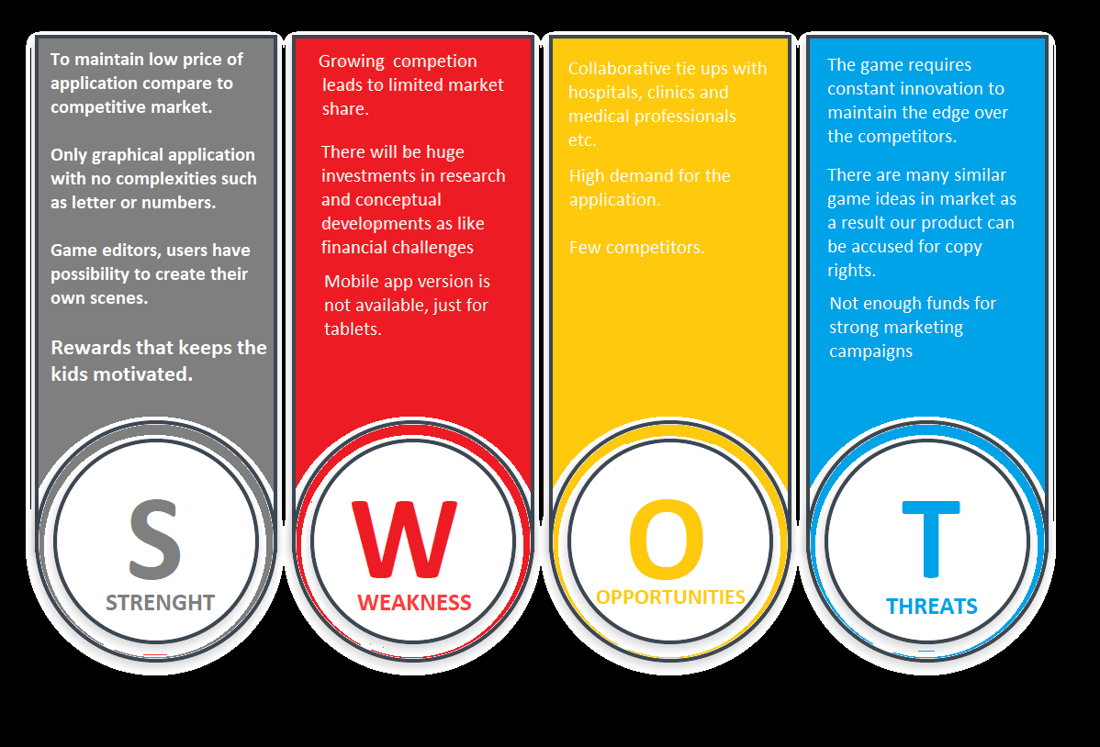Figure 2: SWOT Analysis Graph

## 5. Requirement Analysis

### 5.1 Functional Requirements

We will be providing a gamification concept for the “Digital Hearing Assistant” to help the users- children in the age of 4-6 years, who have just started to learn to hear with a Cochlear implant. This is done by familiarising the children to the application using an animated video or story tutorial, providing various levels of games (based on the child’s capability determined from the initial test)- each game with 3 stages, rewarding them with animated images and measuring their progress.

### 5.2 Technical Requirements

1. WiFi

2. Tablet (of any Brand) with minimum Working Memory of 2GB

3. Operating System: Android (Minimum version 5.0-Lollipop) or iOS (Minimum version 11)

4. ARM processor

### 5.3 Operational Requirements

1. Captive Touch Screen

2. 3G/4G Network SIM Support

3. Storage space of 50MB

4. Basic Tablet usage knowledge

### 5.4 Development Requirements

**Software Interface** that can be used to design our gaming concept is GODOT. It is an open-source, completely free and a unique game-development platform [4]. It has several amazing features, that make it a go-to software to develop our concept. Our Mascot needs to be animated (whenever it appears on the screen) while showing his response to the user- happy, dancing, sad, joyful, etc. And GODOT has the most flexible animation system- it can animate anything! You have the liberty to code in your choice of language- as it supports many scripts. Easy to deploy, can be developed on any OS platform and supports teamwork are the other features of using this gaming software [5].

**Hardware Interface:**

Storage space : 20MB

Operating System : 32-bit or 64-bit Windows, OS X, Linux, etc (any)

## 6. Use Cases

### 6.1 Usage Scenario

The main motive of our project is to conceptualise a “Digital Hearing Assistant” for the 4-6 year old children, with a newly fixated cochlear implant. This is accomplished by providing an educating-gamification concept ranging from the “very basic” up to “little hearing-understanding” capabilities for the child.

### 6.2 Process Workflow Model

The Process Workflow Model, shown below in figure 3, gives us a diagrammatic view of how our gaming aspect of the project, Heidelberg Hearing Assistant will work through a series of steps. In simple words, it helps us to get a clearer picture of how the game will flow- conducting an initial test, doctor analysing and preparing the levels accordingly, the option of watching the tutorial at any point to understand the working of the game, revisiting the reward gallery to maybe revise and finally, the doctor/ therapist monitoring the progress of the child and giving feedbacks.

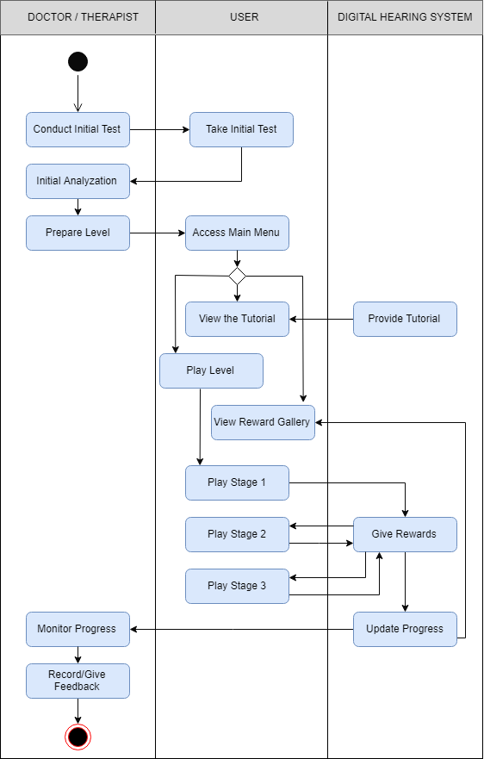

Figure 3: Process Workflow Model

### 6.3 Use Cases

*Table 2: Use Cases*

|  |  |
| --- | --- |
| Number | 1 |
| Task | Initial Test |
| Description | - A very basic fun test of 5-10 questions before the beginning of the actual game.  - Get an idea of the initial level of hearing and understanding capabilities of the kid. |
| Actors | Doctor/ Therapist |
| Result | - Record test results, which helps to analyse progress of the child in the future.  - Design Levels of the games according to the child’s needs. |

|  |  |
| --- | --- |
| Number | 2 |
| Task | Gaming Levels |
| Description | - Generated specifically to a child’s needs  - New Levels added using Editor Feature in an easy, intuitive way |
| Actors | Doctor/ Therapist/ Teacher/ Parent |
| Result | Helps child to learn about more and more sounds through the addition of levels (stages). |

|  |  |
| --- | --- |
| Number | 3 |
| Task | Play a Level |
| Description | - Each prepared Level by the respective care-taker has in-turn 3 stages: Exploring Sounds, Sound Quiz and Finding Sounds  - Successful completion of each stage, leads to rewards for that particular stage.  - In case of getting stuck, Owl, the Mascot will give small hints to proceed. |
| Actors | User (4-6 year old Children) |
| Result | Fun and educative way for the user to listen and learn new sounds. |

|  |  |
| --- | --- |
| Number | 4 |
| Task | Video Tutorial |
| Description | - Different elements and background scenes are presented in form of some kind of animation or a story.  - Basically, it is for a gradual introduction to the functionalities of the application. |
| Actors | Digital Hearing System |
| Result | Provides better understanding and familiarisation to the gaming application’s functionalities. |

|  |  |
| --- | --- |
| Number | 5 |
| Task | Reward Gallery |
| Description | - Incentives to children are given in the form of images for the gallery.  - Children can check the progress status in the main menu>> gallery.  - Anytime can visit the gallery to look at how many images have been collected and also, where they went wrong. |
| Actors | Digital Hearing System |
| Result | A medium to revise and improve ability of recognizing different elements in the future. |

|  |  |
| --- | --- |
| Number | 6 |
| Task | Progress Status |
| Description | Analyzing the progress of the kid from the initial test results to the different Levels the kid has played. |
| Actors | Doctor/ Therapist |
| Result | Can give better feedbacks to the parents/ teachers of these kids. |

### 6.4 Use Case Model

“Use case diagrams are the blueprints for your system” [3].

The Use Case Model shown below (figure 4) is used to depict the interaction between our gaming application system (the Digital Hearing Assistant) and the user, which is a 4-6 year old child, in a simple and graphical manner. It is a high-level view in layman’s terms for the sake of the Stakeholders of this project.

## 

Figure 4: Use Case Model

## 7. Stakeholder Analysis

The following section explores the various stakeholders concerned by this project and their interests. These interests were central to the gamification and education aspects of this software application. The term stakeholder in this context refers to an individual, group or party with a vested interest in the business, product and/or service. Furthermore, a distinction between internal and external stakeholders can be made.

Internal stakeholders are employed by the company in question and hence primarily represent the interests of their employer. In our case the internal stakeholders are made up of the Product Owner and the development team. In extension entities like the finance department or the CEO could be affected by the ramifications of this endeavor and thus could be considered internal stakeholders. This inclusion would be dependent on the size of the company in relation to the magnitude of our project.

The external stakeholders of our project are as follows: Teachers, Therapists/Doctors, Parents, Children (users), implant manufacturer (customer) and other potential users. As suggested by this previous listing the term external stakeholders encompasses entities outside of the company itself. Due to the fact that our group focuses its efforts on “Gamification & Education” external stakeholders like the government, creditors and suppliers are not being considered henceforth.

### 7.1 Internal Stakeholders

#### 7.1.1 Product Owner

The Product Owner is considered an internal stakeholder, yet he often times represents the interests of the external stakeholders within the company. This stakeholder will prioritize the various demands made by the subsequently mentioned external stakeholders while ensuring a certain business value of the project at hand. Concerning this project the Product Owner could focus on the universal applicability of the software for the core target group of hearing-impaired children as well as other potential users. For instance fully healthy children might reap some of the benefits of the application by simply using speakers for the sound output in order to develop their visual and auditory skills and enjoy the gamified features of this learning experience. This widening of the target group is desirable by the Product Owner in order to ensure a faster return on investment. Therefore, during the development phase of the software it can always be monitored if the the application still offers universal value to this wider definition of the potential target group in terms of gamification and education.

#### 7.1.2 Development Team

The development team primarily focuses on an easily maintainable software solution in order to minimize effort in the future, while still offering the demanded functionality. The ease of maintainability will free up capacity of the development team in order to potentially add new features or even focus on entirely new projects. In terms of functionality the development team will adhere to the requirements set out by the Product Owner, which in turn will make the interests of the external stakeholders consistent with those of the company. In this instance one crucial aspect for the development team will be the implementation of an easy to use interface in which the therapists and medical staff can edit and create experiences optimized for each individual user. The more versatile this editor will be designed the less changes or additions will have to be made by the development team in the future. Hence this reduced prospective maintenance will serve the interests of the development team in the long run.

### 7.2 External Stakeholders

#### 7.2.1 Teachers

The teachers as external stakeholders can benefit in several ways from the gamification and education aspect of our software solution. For one thing a teacher may benefit from the educational foundation being laid by this application. The children will already have encountered a learning environment by using the application, thus allowing the teacher to take up the first learning experiences of the youngling and building upon them. One example of this would be the combining and memorizing of visual and auditory stimulations, since the child will enhance these cognitive skills by using our software. A comparable, similarly hearing-impaired child without access to this software would not have been able to train those skills in order to be susceptible to traditional educational techniques often used by teachers like showing objects and voicing the corresponding pronunciation. Hence the teacher can use his or her familiar didactic tools and would less likely be overwhelmed by the task of teaching a hearing-impaired kid. Additionally, a teacher could encourage group-based learning, since the receptivity-gap between fully healthy children and our users would be minimized.

#### 7.2.2 Therapists

Therapists may use our application in order to practice with the hearing-impaired children. A therapist may show interest in the gamification aspects of our software project, since this should not only maximize the learning progress of the users while using the app but should also encourage them to use to train for longer periods of time and more frequently. In turn a child motivated to using this learning tool will be a lot easier to keep engaged and provide helpful therapy to.

Another beneficial functionality in terms of gamification and education is the ability to custom-build levels for the kids to explore. The design of such levels can be a collaborative effort of therapists and doctors alike. They expect an intuitive building tool for such levels in order to easily adapt the learning experience of the patients. Such an ease of use could even result in re-adjustments within sessions, thus further helping the doctors and therapists to utilize more of their expertise in order to tap the full potential of their patient.

### 7.2.3 Parents

The parents as an external stakeholder could be interested in the implementation of practically relevant learning content, since they will experience their child in a real-world setting. For instance, a city center might be rather overwhelming for a young kid not used to the vast amount of varying sounds. Our application ought to prepare the child for such scenarios in order for the parents to be able to easily take their offspring to a downtown doctors appointment. Hence one could assume that parents would rather have their child educated by the use of real-world data rather than more unusual content e.g. the sounds of zoo-animals.

### 7.2.4 Users

As the users, the children themselves are a crucial external stakeholder. The entertaining nature of the application should fuel their curiosity and help create positive associations towards their implant. Prior to using our software, the children might not have made pleasant experiences in the field of hearing aids, since there probably have been numerous doctors appointments which are usually boring or even unpleasant to young children. Our gamification and achievement system are aimed at serving this purpose and help the kid explore the possibilities of the implant while having fun in the process. Furthermore, a sense of pride can arise towards these new learnt abilities. Another benefit could be the application of the newly learned skills in various other learning efforts. Additionally, building relationships with other children should come easier to the boys and girls due to the reduced social barrier in the form of a hearing-impairment.

### 7.2.5 Implant Manufacturer

The implant manufacturer has an interest to keep the educational value of the exercises to a high standard. This way their implants could be advertised by highlighting their support for software aimed at the prosperous development of children and their skills. In addition, the gamification aspects might increase customer satisfaction and usage rates of their implants. This, in turn, could result in higher market shares or the ability to raise prices for their implants due to the additional functionality of the product. Lastly the manufacturer of the implants would want the educational content to be kid friendly in order to avoid legal expenses. Should their customers feel like their children were traumatized e.g. by a scary tiger roar, negative publicity and lawsuits could ensue and damage the company.

### 7.2.6 Other Potential Users

Lastly other potential users e.g. fully healthy young children could benefit from the application should it be used with speakers instead of implants. The interests in this case would mainly focus on the pleasure of using the app and the resulting improvement of cognitive skills. In contrast it would not be an interest to avoid negative sensations experienced by moving in the real world, since healthy kids have the abilities to naturally adapt to their environment.

### 7.3 Influence and Impact of Stakeholders

The chart below shows the influence and impact of the different stakeholders on the project.

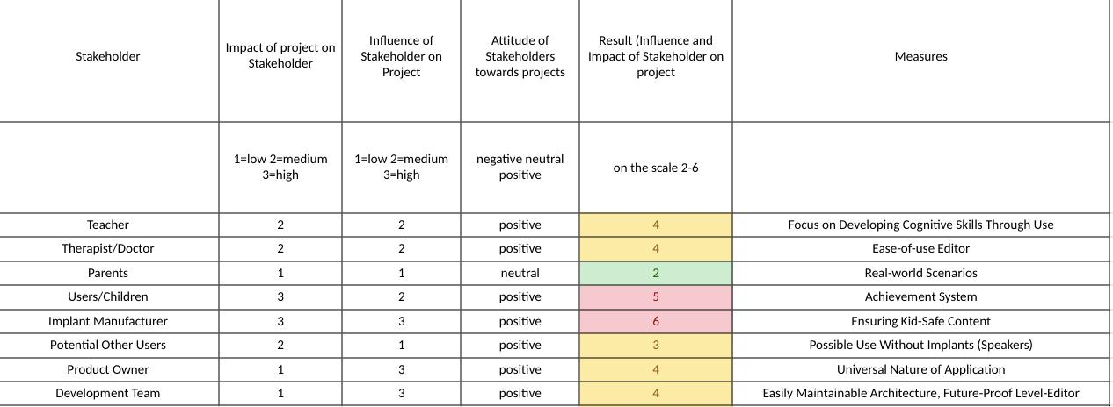

Figure 5: Influence and impact of stakeholders

## 8. Project Methodology

### 8.1 Agile Methodology

“Agile Methodology” is a way of approach in project management, very popular in particularly, IT project management. It has a team based, iterative approach emphasizing on rapid delivery of the application. One of the reasons of the agile approach being popular is its flexibility in an SDLC. Iterations are used as way to develop and improve the application in agile. The iterations are nothing but list of deliverables which are to be completed in a time frame known as sprints. Each sprint has planned tasks and work is reprioritized in the next sprint, if the tasks cannot be completed. Projects using agile methodology usually gives results closer to the customer requirements, mainly since the customer involvement and communication in the project is required, the involvement being the feedback in the sprints. This also allows the customer’s requirements to be changed late in the SDLC.

Advantages of using Agile:

* Continuous delivery of valuable software, as customer is involved in the project.
* Each sprint is evaluated, and successive sprints increases agility also helps in fixing/solved bugs much early.
* Primary measure of working software is the progress made.
* Changes to the project are welcome even in late development cycle which mitigates certain technological risks in the future.

Disadvantages of using Agile:

* The team members need to be highly skilled in various areas, they also need to be dedicated to the project.
* A good amount of involvement from customer and commitment is required.

**Why use an agile approach ?**

The project “Digital Hearing Assistant” is divided in certain teams which are assigned special roles. Sequential methodologies such as waterfall, V-model are easy to manage but are used where projects have defined requirements where no changes are expected, also every phase in the project development needs to be completed before starting the next phase. Agile methodology, on the other hand, are more flexible in structure and are used where requirements are expected to change in any phase. The teams may initiate work on the present(limited) information. The development strategy can also be reiterated using sprints to improve the shortcomings of the previous sprints while designing and development running parallely. The project has to be planned well in agile approach but doesn’t need to be as detailed, unlike the waterfall model.

### 8.2 Milestones

A milestone is an important event that signifies progress in a project. They are checkpoints which can propel a project towards completion. Milestones planning help project the progress of the report. Milestones not only includes deliverables but may also include deadlines or approvals. Following are the planned milestones for the project:

* Gathering complete user requirements and analyzing Moscow, SWOT, Budget, Risks and Budget plan.
* Completing the design (planning the UI design and wireframe , application functionality, animations ).
* Initial Delivery - Integrating the UI/UX concept and development plan to create a working structure. (phase 1)
* Completing the testing, changes and updates based on feedback and additional features.(phase 2)
* Documenting all the technical, functional features as per the requirements.
* Deployment of the application.

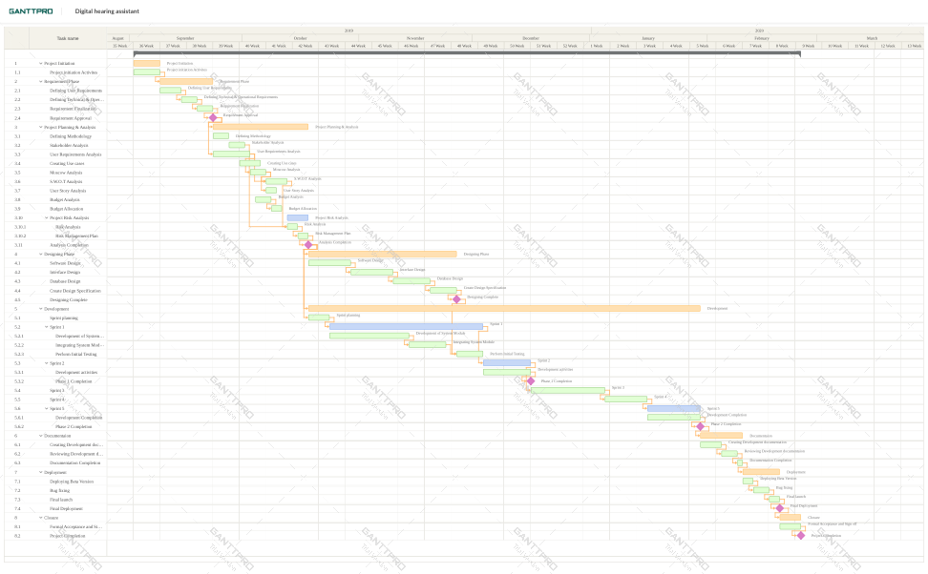

Figure 6: Gantt Chart

Figure shows the structure of the Network Plan. The Network Plan/ Gantt Chart is used to breakdown the project management phases into various work packages/activities and defines the milestones with timelines.

### 8.3 Project Plan

### 

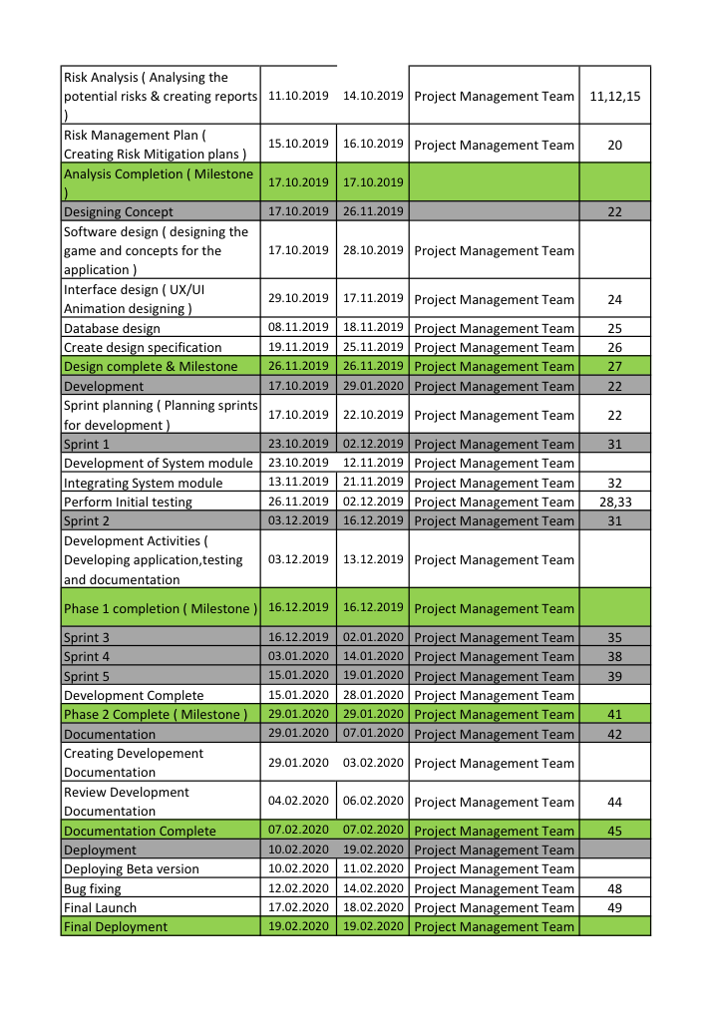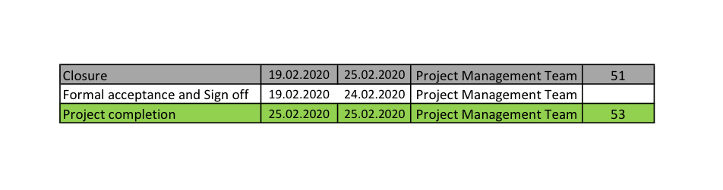

Figure 7: Project Plan

## 9. Risk Analysis

Risk can be defined as any event with a possibility of occurring, leaving a positive or negative impact on the project if it occurs. Almost every project have to assume some degree/level of risk that might impact the outcome of the project in many ways, such as the project cost, schedule, performance or even derail the entire project. That is why “Risk Analysis” is used to predict those events that might have an impact on the outcome of the project. Risk Management is continuously used throughout the project life. It includes processes for risk management planning, identification, analysis, monitoring and control. During the risk analysis process, some events may affect or have a probability of affecting the project in a positive way. Such risks are also identified and exploited in favor of the project.

### 9.1 Risk Management Plan

**Risk Identification:**

An important part of risk management plan is risk identification, consists of determining the risks likely to impact the project. Also the identified risk needs to be documented. The identified risk should also be brought to attention to the manager and project team involving any risk factors or events.

**Risk Assessment:**

Risk assessment will include the analysis of the identified risk, that is determining the probability and impact it will have if it occurs. The scope of the risk is also defined.

**Risk Mitigation:**

Now that the risk has been assessed, the risk needs to be mitigated. Risk mitigation has two steps:

1. Identifying various activities or steps, to reduce the occurrence or reducing the impact of the risk.
2. Creating a Contingency plan for dealing with the risk when it occurs.

Some risks can be avoided or mitigated by taking early steps which in turn be more effective or less costlier than trying to fix the damage, after it has occurred.

**Risk Contingency plan:**

Contingency plan is an action plan to or series of steps that can be performed in case of an adverse risk occurs. Planning for a contingency forces the project team to follow the course of action in case of a risk.

1. Preparing ( Action on preparatory steps ) for the implementation of the Risk Mitigation strategy.
2. Project resources should be determined.
3. Define a Contingency Plan and layout the necessary emergency protocols.
4. Document the Contingent plan, inform the management and regular reviews of the plan should also be performed.

**Risk monitoring and reporting:**

The risk management in any project is an ongoing process throughout the life cycle of a project which includes all the process of the risk management plan. The risks will be tracked, monitored and reported for the entire project cycle based on the trigger events documented in the risk analysis and assessment. Risk will be communicated to the project team and contingency plan will be enacted if required.

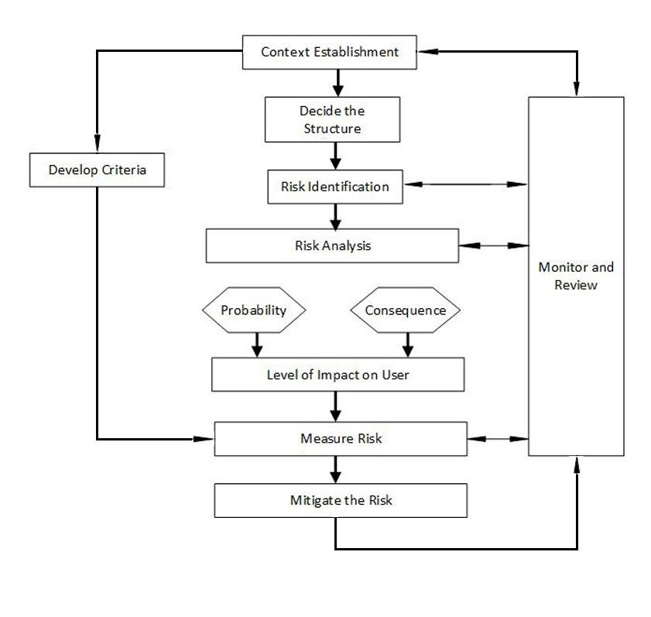

Figure 8: Risk Diagram

*Table 3: Risk Analysis and Mitigation*

|  |  |  |  |  |  |  |
| --- | --- | --- | --- | --- | --- | --- |
| **Risk**  **No.** | **Name of the Risk** | **Risk Description** | **Risk Potential** | **Risk Probability** | **Impact on User** | **Mitigation**  **Strategies** |
| **Process and Management Risk** | | | | | | |
| R1 | Improper project schedule | Every project has a fixed deadline. If the time gets delayed, it’ll generate more competition which will lead to huge loss. | Marginable | Medium | Low | The project workflow should be optimized. |
| R2 | Lack of Sufficient Resources | During the development of the project maybe the resources are insufficient to finish the task in time. | Critical | Low | Low | We have to hire new staff, contractors who will support in development of the project. |
| R3 | Sudden change in Requirement | If the requirement of the user changes or the company plans to go another way to attract customer it’ll affect the project. | Critical | High | Low | Convince the customer that this platform can improve the business perfectly. |
| R4 | Change in Politics | Sometimes overlapping government function can have impact on business. | Catastrophic | Medium | Low | Keep familiar relationship between business and political authorities is a cooperative arrangement. |
| R5 | Negative feedback from customer | If the customers were not satisfied with the application then they’ll give negative feedback to the product which may leads to poor marketing. | Catastrophic | High | Low | Make spontaneous improvement in the application and respond to the customer quickly. |
| **Technical Risks** | | | | | | |
| R6 | Compatibility Issue | Due to rapid change in technology the application may not work on the user’s system. | Critical | Low | High | The user has to buy the compatible device. |
| R7 | Memory management | Because of high collection of graphical data and frequent updates there might be problem with memory management depending upon the size of the user’s hardware. | Marginable | Low | High | The user has to either increase the memory space by removing other data or have to buy a new device. |
| R8 | Application Crash | Sometimes due to some unknown reasons the application stops working or crashes. | Critical | High | High | Find where the trouble has been generated and ameliorate it as soon as possible. |
| R9 | Battery Backup Issue | Due to the usage of more graphical data, the battery may drain out quickly. So, it’s an obstacle in learning process of the child. | Marginable | Low | High | The user has to buy new device if the battery drains out very quickly and the user can also keep on the Battery Saver Mode. |
| **Users Experience Risk** | | | | | | |
| R10 | Bacterial Meningitis | The Food and Drug Administration received reports of bacterial meningitis in children who were less than six years of age with cochlear implants for treatment of hearing loss | Catastrophic | Low | Extreme | Health care providers should ensure that all children who receive cochlear implants are appropriately vaccinated and treated promptly for bacterial infection. |
| R11 | Children’s Understanding | A child might face difficulty in understanding how these application works | Marginable | High | Low | The parents should guide their children to become more friendly with the application |
| R12 | Neurocognitive risk in children having cochlear implant | In most domains of executive functioning, children with Cochlear Implant were at 2 to 5 times greater risk of clinically significant deficits compared with children with Normal Hearing. | Critical | Low | Extreme | Screening for risk of executive functioning deficits should be a routine part of the clinical evaluation of all children with deafness and CIs. |
| R13 | Obsession with the Games | It is a common sight today to see children glued to a digital device for hours. This is causing serious damage to children | Critical | High | High | The parents should limit their time for using of smartphones, tablets and encourage them to do other activities. |
| R14 | Magnet Displacement | The magnet of the cochlear implant gets displaced, then it’ll cause minor central balance disorder and neuromuscular weakness. | Catastrophic | Low | Extreme | They have to do an MRI scan and then replace the magnet with another one. |
| R15 | Limitation in Learning | After a child finishes all of the levels of the game, Then the application will be worthless to the child. | Marginable | High | Low | The developer should create levels or new game spontaneously so that a child can enjoy learning unendingly. |

### 9.2 Risk Assessment Matrix

*Table 4: Risk Assessment Matrix*

|  |  |  |  |  |
| --- | --- | --- | --- | --- |
| Probability | Negligible | Marginable | Critical | Catastrophic |
| Low | Low | Low | Medium | High |
| Medium | Low | Medium | High | Extreme |
| High | Medium | High | High | Extreme |
| Extreme | High | High | Extreme | Extreme |

### 9.3 Risk Matrix Grid

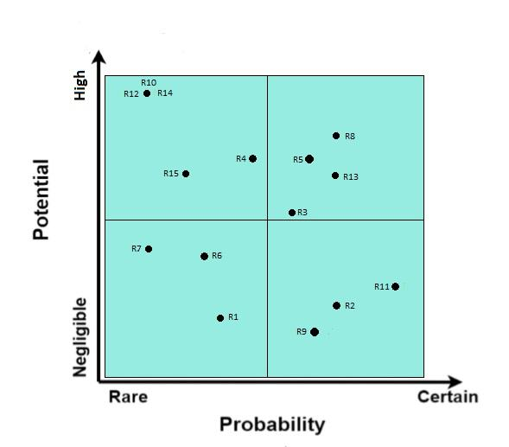

Figure 9: Risk Matrix Grid

## 10. Gamification & Education Concept for the Digital Hearing Assistant

This section describes the main idea and functioning of the concept, developed for the Digital Hearing Assistant App, with focus on the gamification & education aspects.

### 10.1 Gamification Aspect

“Gamification is the use of game design elements in non-game contexts”[1] . Typical game design elements could be high scores, digital rewards or progress bars. By integrating them in a playful manner, their main use is to keep the user motivated and provide them with various and even more challenging tasks. Additionally, the gamification aspect of an application could significantly improve the learning effect of children.

### 10.2 Game-based learning

The term education in combination with games is what defines game-based learning, it is of ever-increasing importance. If you think of children you only expect them to learn at school, while they play games to have fun in their free time. When using educational aspects in games, children are motivated to learn without really realizing it, because of the games ability to hide the educational aspect, by presenting it in a playful manner.

#### 10.2.1 Education Aspect

Before developing a concept for a game where children learn the ability to hear, it should be clear what they are exactly learning and how it can be evaluated to further improve their hearing:

* **Image Relation:** Make a relation between elements and the sound
* **Different Pitches:** Gaining the ability to be able to hear a wider range of sound frequencies
* **Task on sound:** Make the child react and perform various to different sounds
* **Evaluation & Optimization:** Evaluation is done by the doctor, he is able to adapt the application to the child needs.

All the bullet points mentioned above are also part of the application and will be explained in detail.

#### 10.2.2 Relation to Hearing Tests for Children

The different education aspects also have a relation to the current methods for hearing tests used for testing children's hearing ability.

**Visual Audio Reinforcements:**

This method is often used for children in a very young age. Its purpose is to teach the kid on how to make a relation between images and sounds, by rewarding it with some visual reward.

In a second stage these sounds are varied in pitch and volume, so that the doctor is able to see if the kid is still reacting to the different sounds. [2]

#### Play audiometry:

Similar to the visual audio reinforcements, the child is rewarded upon the completion of a specific task related to the audio played. Also here the volume and pitch is adapted to see if the kid is still able to complete the task.

Both of the tests mentioned above should be in some similar for in the application.

### 10.3 Gamification & Education in combination with “Digital Hearing Assistant App”

As the main responsible for the gamification & education concept, our main task is to find a intuitive game concept that we could provide for other groups, so that they can then continue working on the realization of the concept. In the following sections, we will go over all the aspects that the game should include to be educative and to keep the user motivated to continue using the application. In this special case, the learning aspect is mainly focused on improving a child's ability to hear and recognize different sounds. Since the target age group is between 4-6 years old, the game should be understandable without knowing how to read or speak.

In the following subsection we will go over the main concept of the game, including all the different game aspects. It is crucial to know how the game works, how the children keep being motivated, what do they learn and how their progress is measured.

### 10.3.1 Game Functionalities Overview

The main goal of the application is to have a fun and progressive environment for children to develop their hearing ability. Therefore the game is divided into 4 progressive stages:

* **Stage 0:** Initiation Test
* **Stage 1:** Exploring Sounds
* **Stage 2:** Sound Quiz
* **Stage 3:** Finding Sounds

All the different stages need to have some kind of content, this is why we decided to use a simple structure that could later be used in a dynamic way:

* **Elements:** Cut-out pictures of objects, animals or humans
* **Scenes:** Backgrounds where the elements can be put on (e.g Beach, Sky, Forest)
* **Sounds:** Sounds matching to the elements (e.g. cat sound, plane sound, talking)

The creation of levels, which contain all the different stages with elements, scenes and sounds can be done in two different ways:

* **Preset:** A preset level is a default level, already contained in the application created for users. This also includes the initiation test.
* **Prepared:** Levels can be prepared by the doctor/therapist, so that they are adapted specifically to a child needs. This is done with an editor where they can build levels in a simple and intuitive way.

In the following sections the functionalities of stages, levels and content will be explained in detail.

#### 10.3.2 Stages

**Stage 0: Initiation Test**

Before the child starts using the application for the first time, the doctor should be informed about the current status of the child's hearing ability with the cochlear implants. Still there also need to be a way to make sure that the child is a least hearing something, in order to use the application.

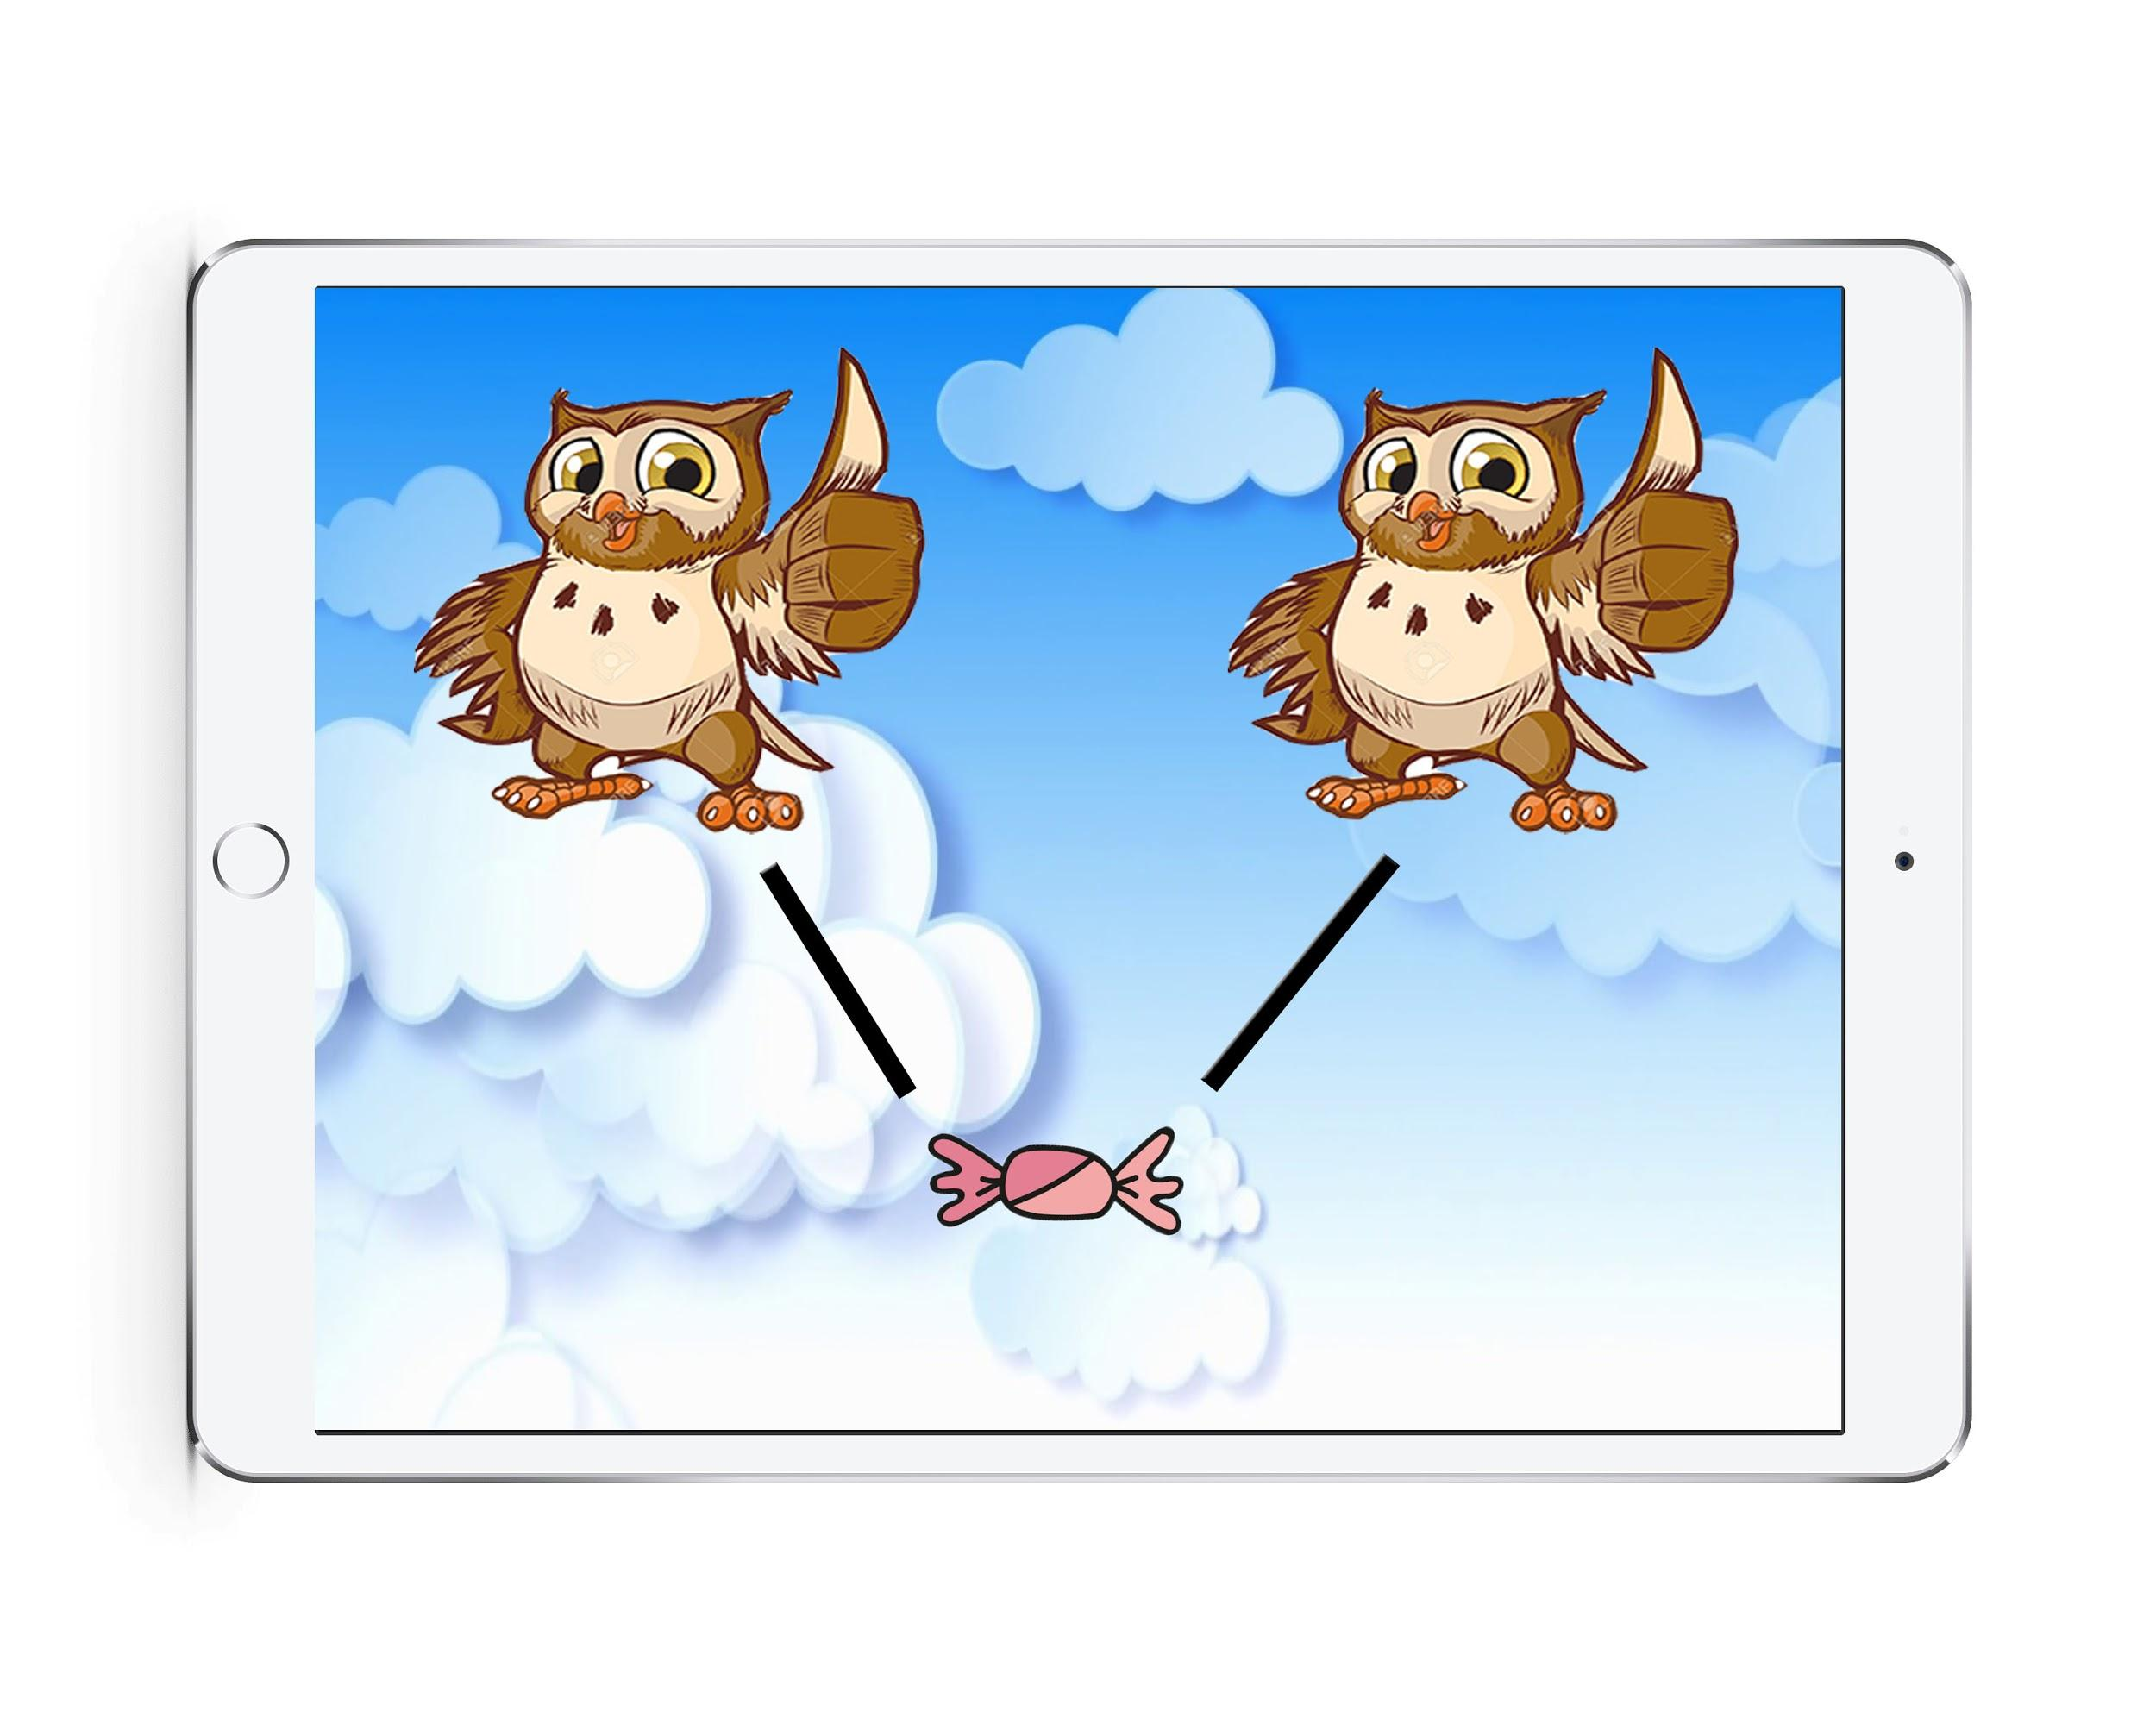

Figure 10: Initiation Test

Figure 10 shows the idea of an initiation test there the child has the simple task to feed the owl with candys. Upon completion the owl will make a sound a give a reaction. The other owl on the other hand is only showing the animation but not playing the sound. After the candy has been feeded, a new candy will appear and the child has to repeat the task. After a certain amount of candy the initiation test is over and a result in form of candys will be shown beneath each owl.

This allows the doctor to find out if the child reacts to the sound by giving the noisy owl more candy than the other one. Of course the sound the owl play should vary in pitch and volume. This stage should be considered as optional.

**Stage 1: Exploring Sounds**

In the first stage, the user will see a scene containing a specific amount of different elements, each element has a different sound. The goal is to let the user explore all the different sounds of the elements.

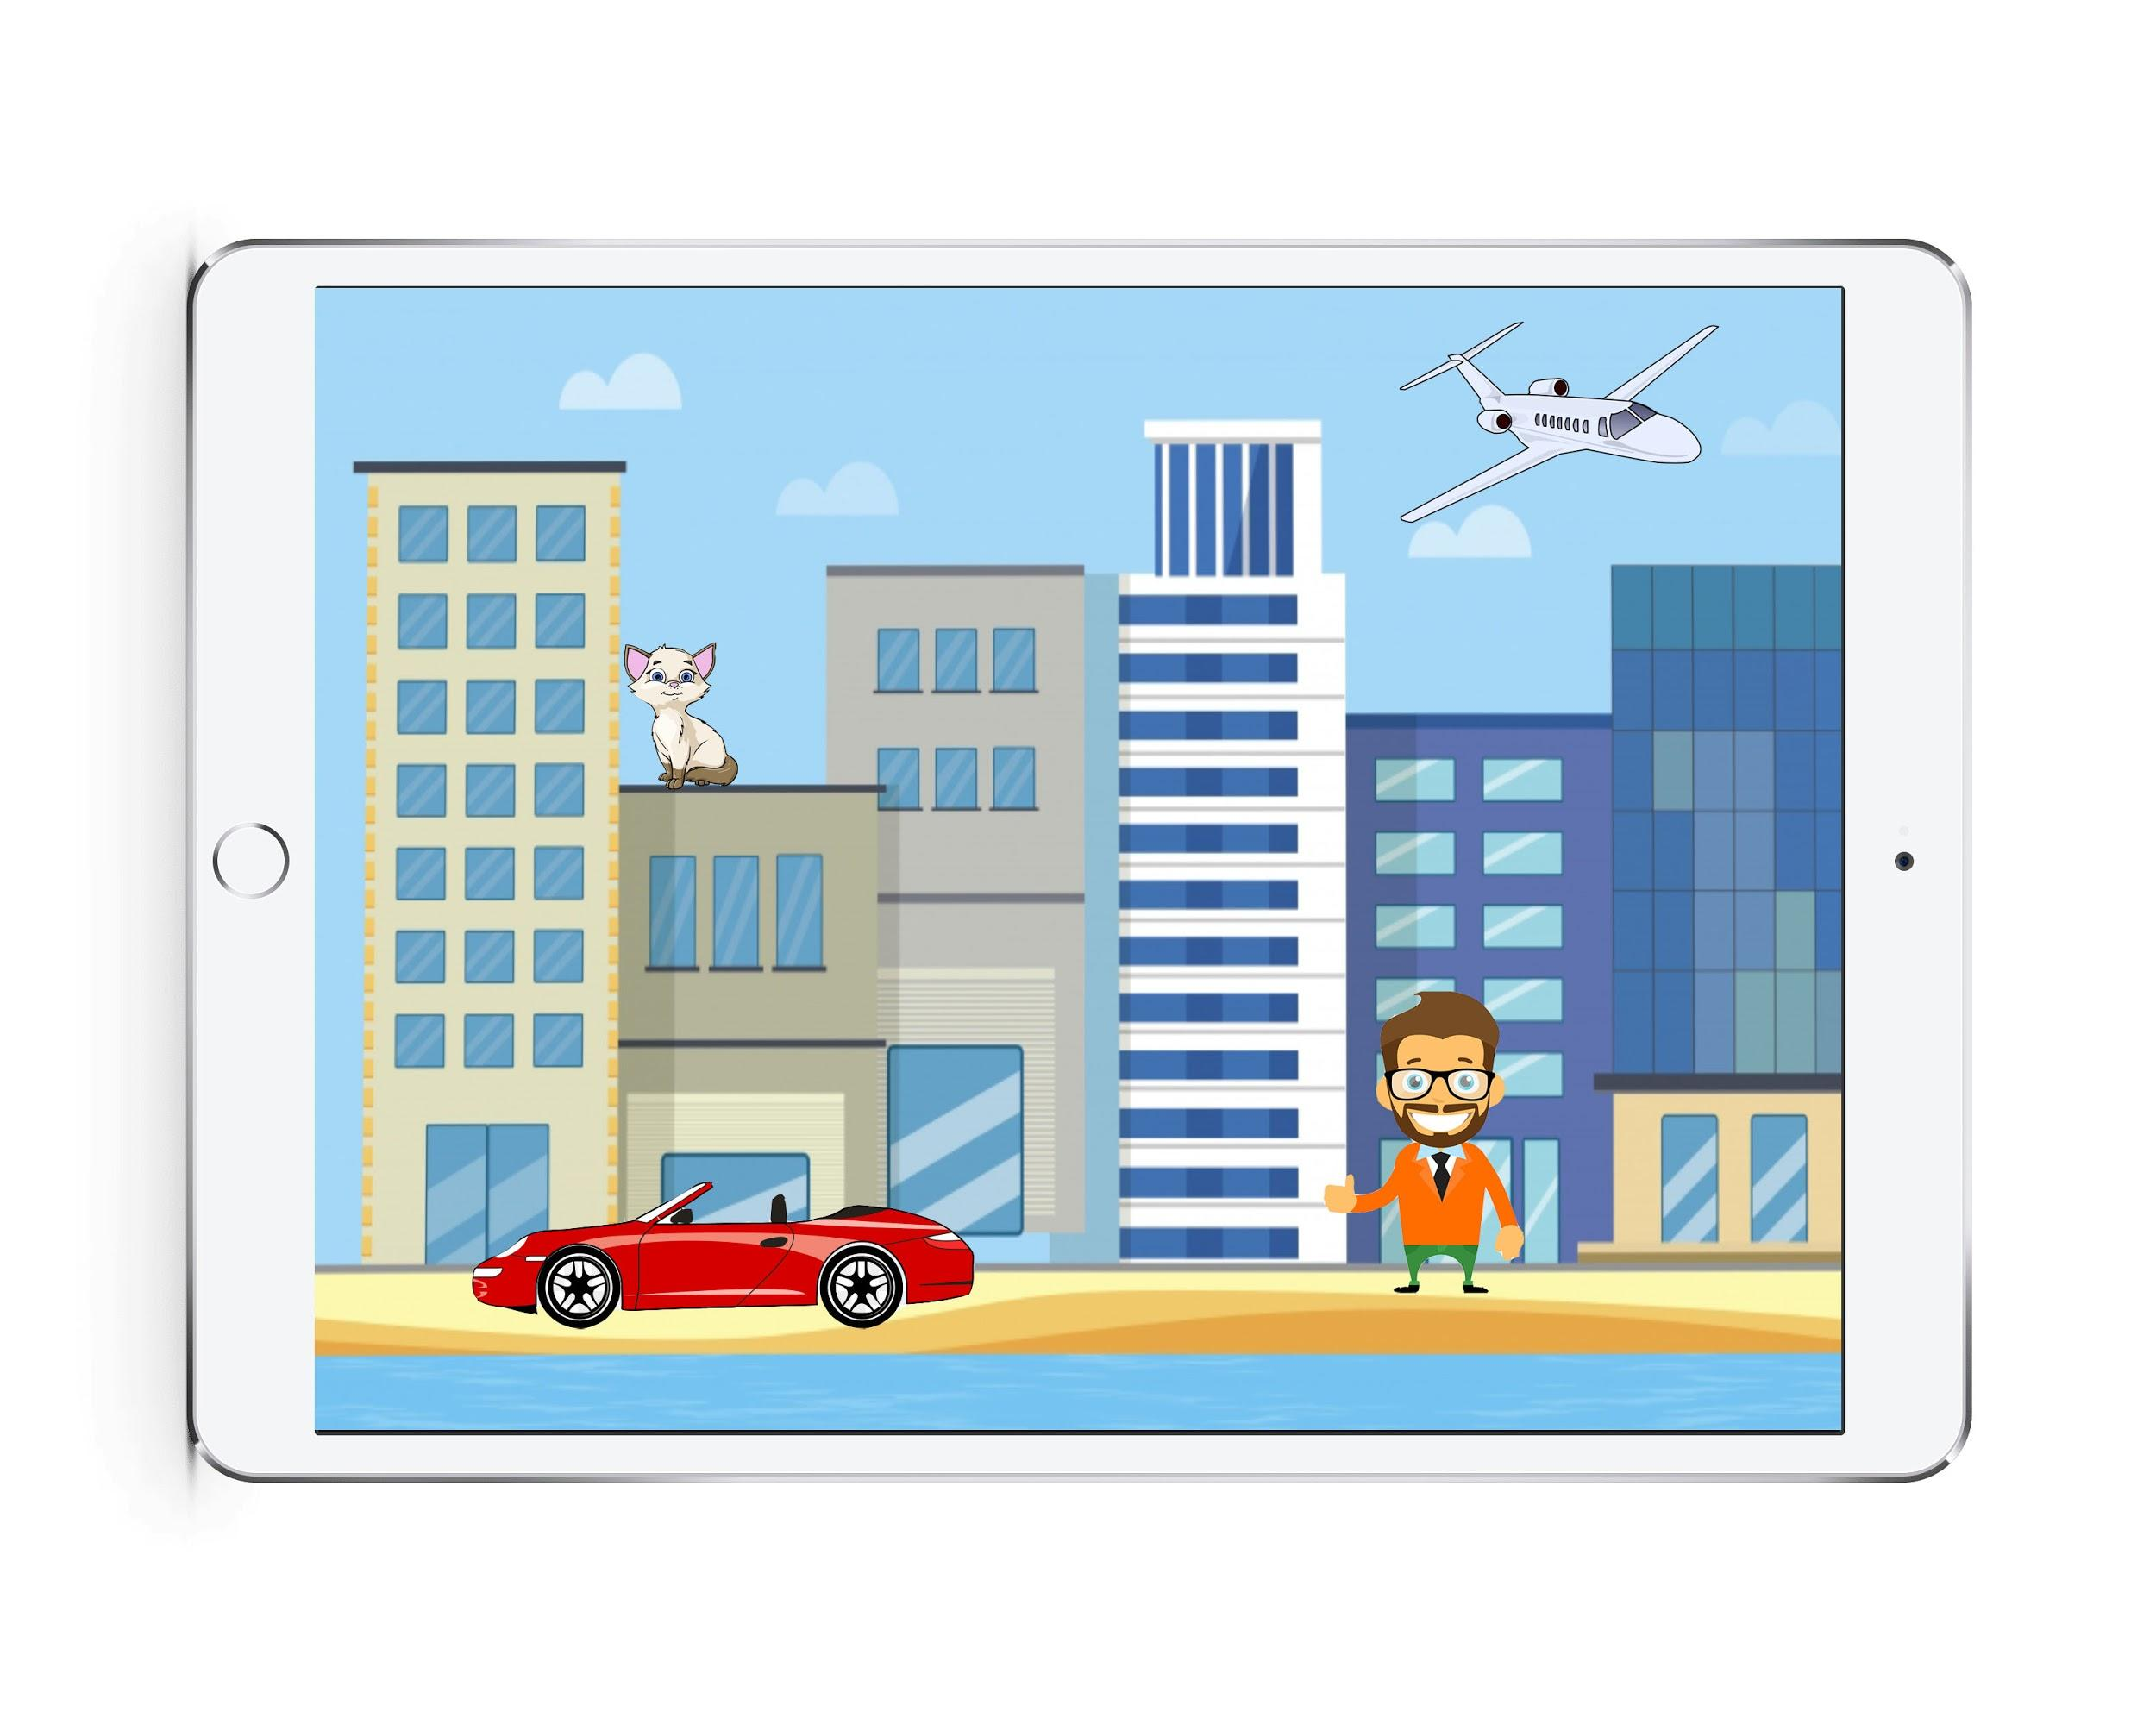

Figure 11: Sample Scene Stage 1

Figure 11 shows an example of how such a scene could look like. The background used for the scene is a city. The elements that were put on the scene are a plane, a cat, a car and a human. All these different elements have a matching sound that the user is able to hear, the moment he touched the specific element on the screen.

During this first stage, there are no real difficulties, the main goal is to let the user explore the sounds. After the user feels comfortable with the sounds and he found/touched all the different elements that are interactable on his screen he is able continue to the second stage.

**Stage 2: Sound Quiz**

After stage 1 is successfully passed by the user, the screen will change to stage number 2 which is a quiz using all the different elements that were contained in the 2nd stage. The quiz consists of 2 or more elements shown at the same time. The user will here one of the matching sounds of the elements shown on screen and he must choose the matching element to the sound. The sound is played in an endless loop and there can be multiple sounds for the same element.

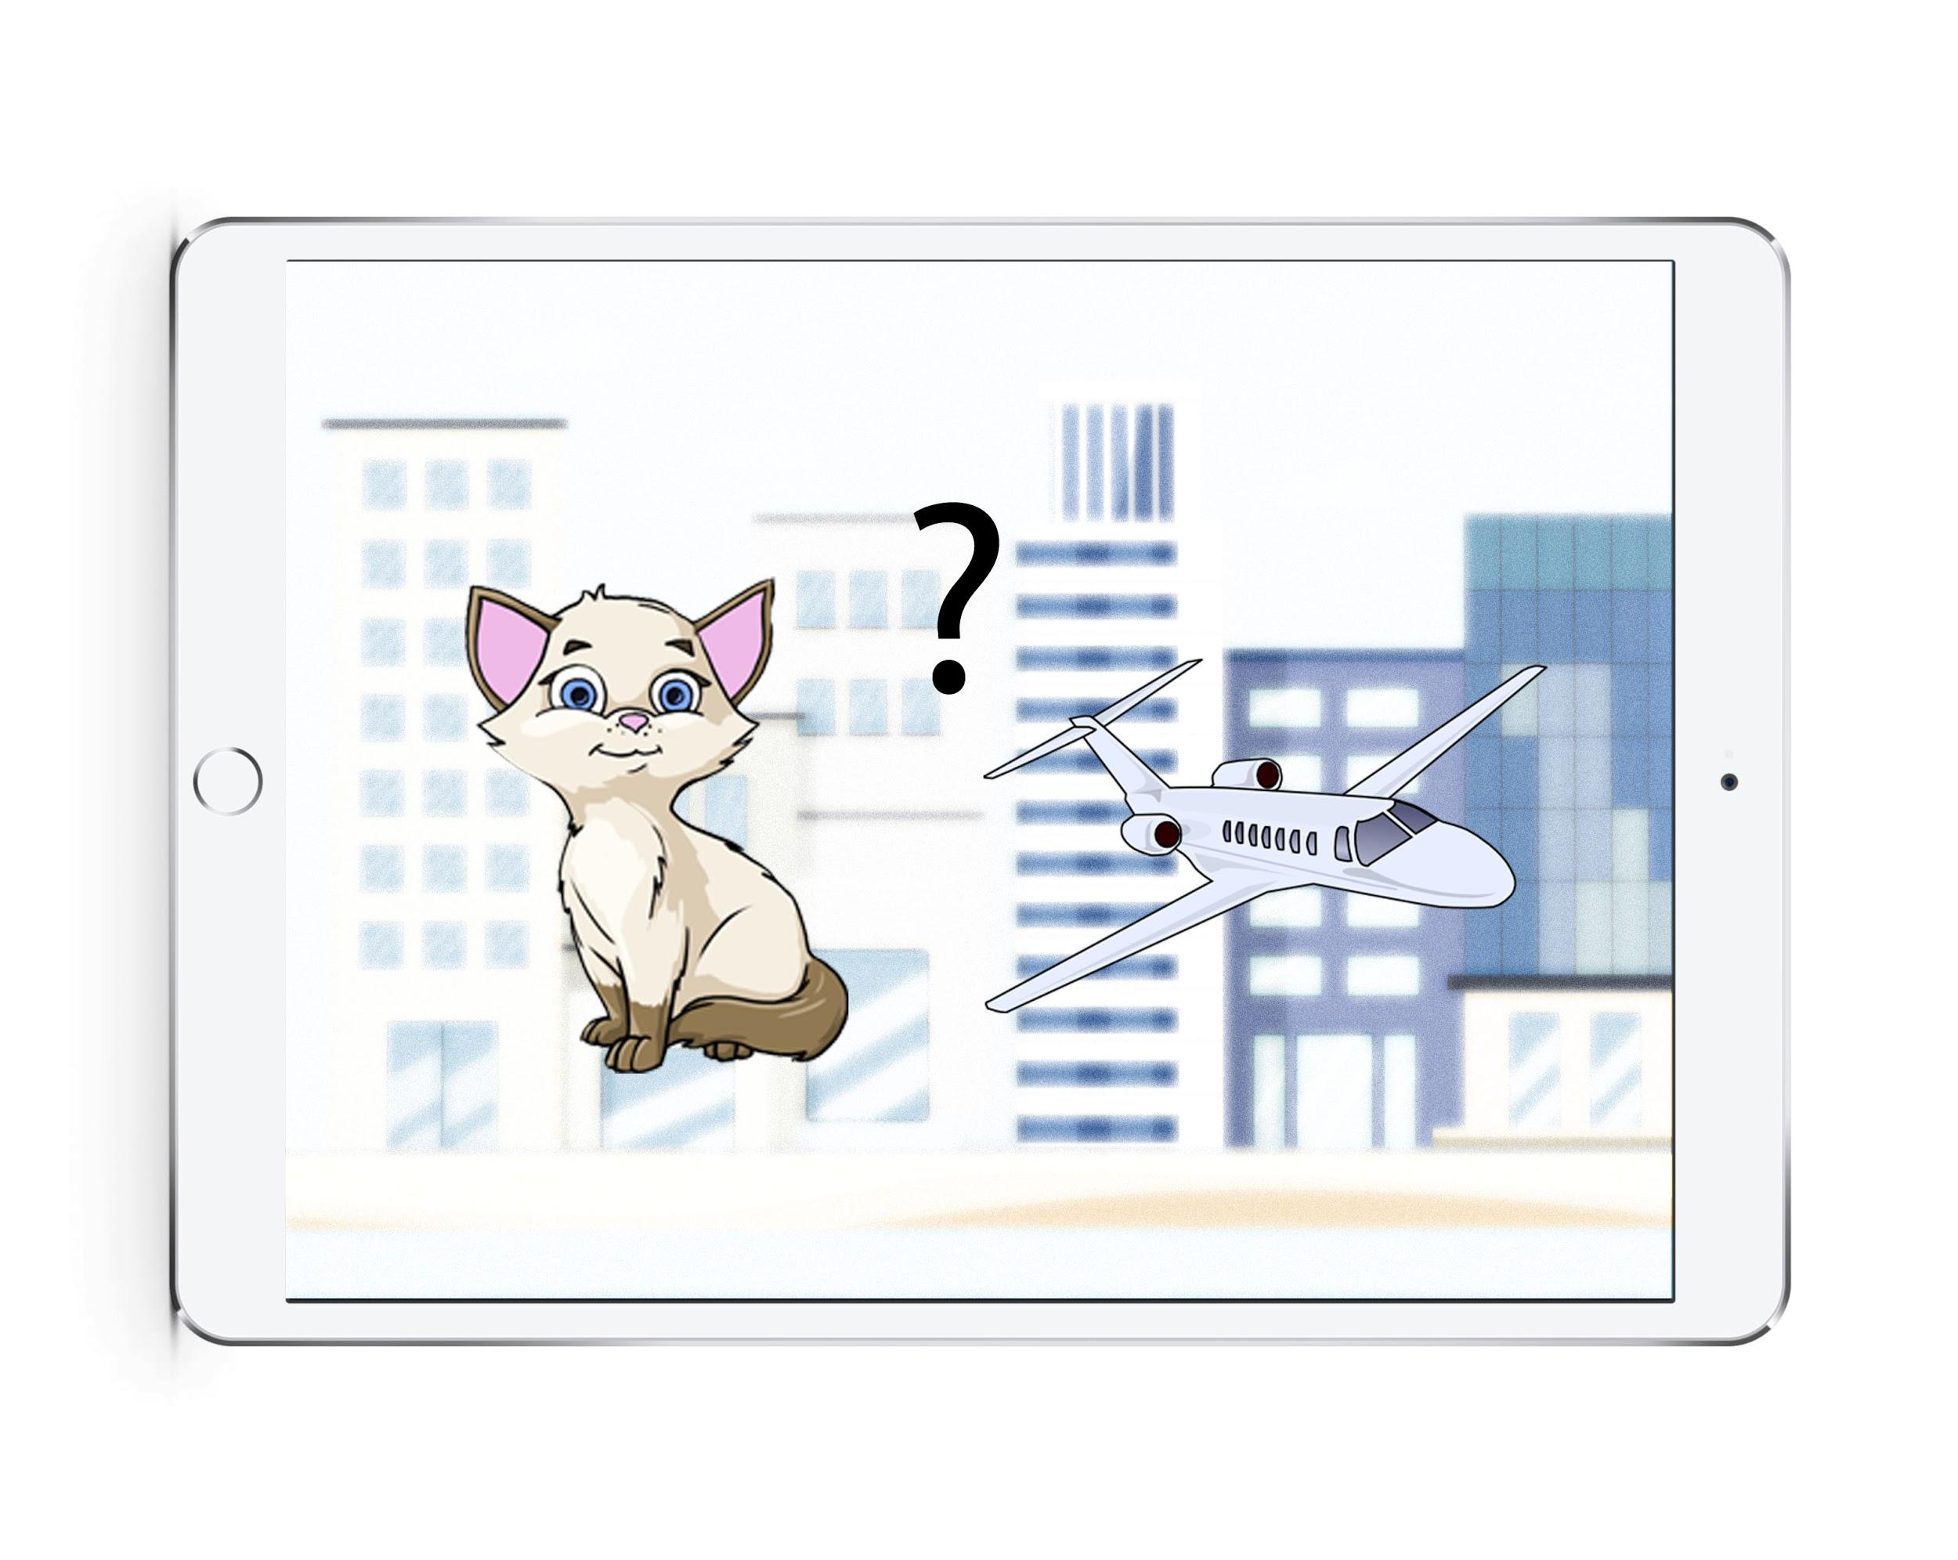

Figure 12: Quiz Sample

Figure 12 shows an example of how such a quiz could look like. On the screen you can see two different elements taken from the scene of stage 1. In this case, the cat and the plane elements. The user is able to hear one sound (e.g. the cat) and then needs to touch the corresponding element.

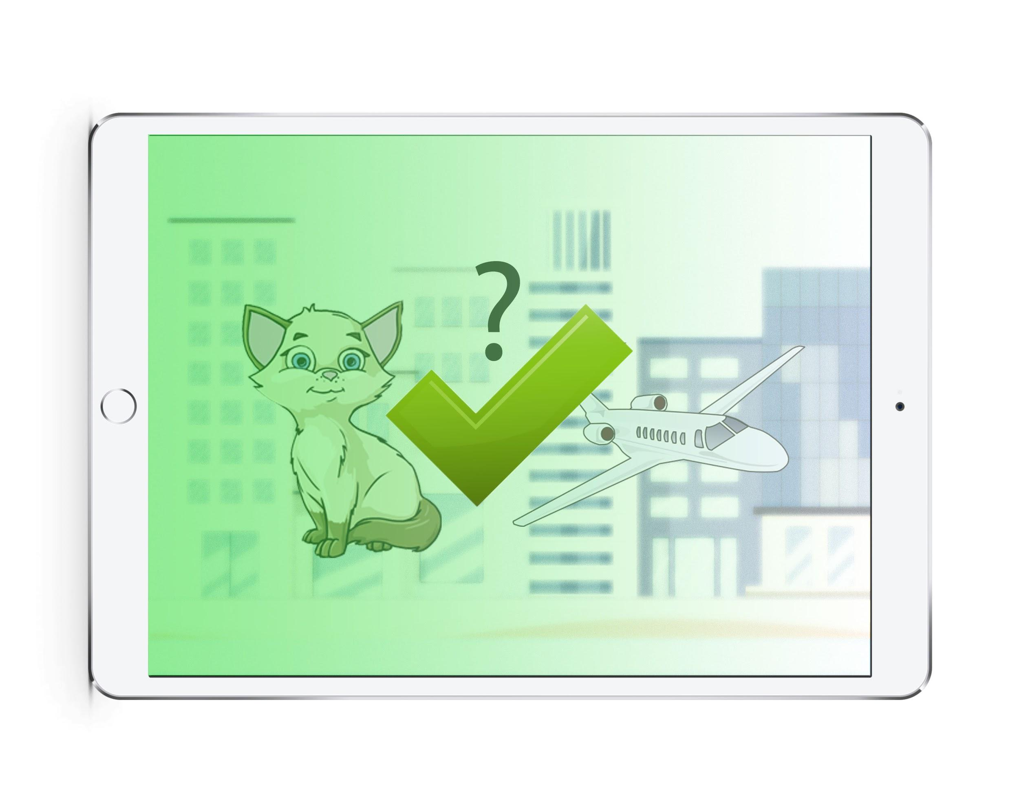

Figure 13: Correct Quiz Answer

The figure 13 shows how it could look like when the correct answer was chosen by the user. Upon completion of one question, two new elements are chosen from stage 1 and put into this quiz format. After all the different elements have been asked at least once in the quiz stage 2 is completed and the user will proceed to stage 3.

**Stage 3: Finding Sounds**

Stage 3 is based on the popular game “Finding Waldo”, it consists of finding the person “Waldo” in a big picture where you can find a lot of different element.

The stage 3 is based on the same principale: Just like in stage 1, you have all the different elements in a scene. The user is then able to hear a repeating sound, matching to one of the elements show in the sceen. His task is then to find the corresponding element to the sound. As a reference on how it could look like you could again take a look at figure 9.1.

### 10.3.3 Reward System

Every game needs some kind of reward to keep the user motivated so that he keeps on using the application. In this specific case where we need to build an application for kids, highscores or progress bars won’t work since children with the age of 4-6 won’t understand the meaning of it.

#### 10.3.3.1 The Reward Gallery

To have a reward that is at the same time fun, interesting to collect, and also educative, the gallery is a good solution to show the users progress.

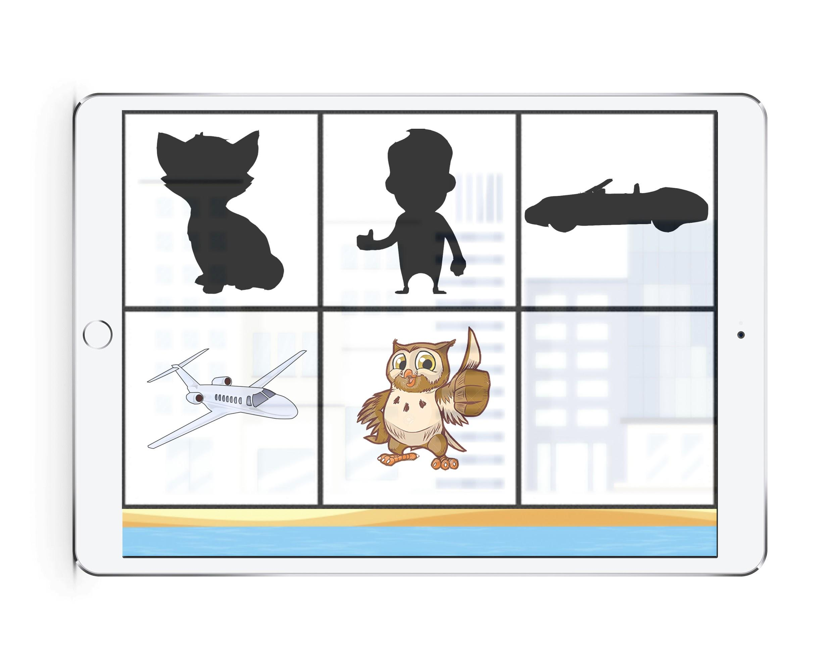

Figure 14: Example Gallery

The figure 14 shows an example of how this gallery could look like. In the gallery you can find the elements that were also presented in figure 9.1. All the different elements that the user found during the three stages can be collected as an image in the gallery. There are three different sorts of elements that can be unlocked:

* **Blacked-out Image:** A blacked-out representation of the element
* **Normal Image:** The normal representation of the element
* **Animated Image:** A small animation with the element (Moving or sparkling)

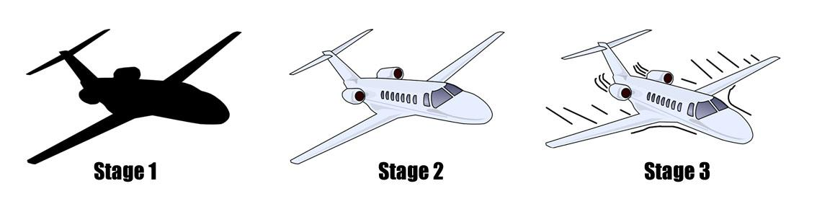

Figure 15: Different Image Stages

As shown on Figure 15, the different images can be unlocked by completing the stages 1 to 3 and correctly answering in the quiz of the 2nd stage. For example, the user sees the element “plane” for the first time in the 1st stage and successfully clicked on it, he will get the blacked out image of the plane for his gallery. Successfully recognizing the plane in the stage 2 quiz then rewards the player with a colored image of the plane for his gallery. The same goes for stage 3, were he then gets an animated plane.

#### 10.3.3.2 Rewards with Educative Background

Rewarding the children with images for the gallery, resembles collecting stickers for a sticker album. It is clear how the progress is shown, since they can always visit the gallery and look at how much they collected and also what they did wrong, e.g. only having a stage 1 reward.

Also important is the fact that the gallery allows the user to select the image and hear the corresponding sound. This allows them to have kind of a revision to improve their ability on recognizing different elements.

### 10.3.4 Tutorial Features

A potential risk could be that the child using the application may not understand what to do during one of the 3 stages. To eliminate this potential risk as best as possible, it is important to have some kind of tutorial. Here we distinguish between two different tutorials:

* **Introduction Tutorial**
* **Continuous Tutorial**

#### 10.3.4.1 Introduction Tutorial

The introduction Tutorial consist of a preset level that is build in a more complex way than other levels. With help of a story in form of some kind of animations of the different elements and background scenes, the child is slowly introduced to the functionalities of the application. The introduction tutorial can also be seen as stage 0. This point could be seen as further development.

#### 10.3.4.2 Continuous Tutorial

In order to help the user passing all the different stages, maybe there is continuous help needed. A mascot with different animations should always be present to help the kids, if they are stuck and they don’t know how to proceed. For exactly this purpose, a mascot was chosen that appears over and over during the usage of the application.



Figure 16: Owl Mascot [6]

Figure 16 represents a potential idea for a mascot that could be used for this purpose. In this example we take an owl, since it is an animal with very good hearing ability.

This mascot will appear in several different parts of the application, namly stage 1-3. The mascot has different purposes that the mascot serves for simplifying the usage of the application:

* **Stage 1:** The mascot helps the user to find elements that haven't been touched yet. For example we have the plane, human, cat and car. The kid touched 3 of the 4 elements, so it is missing 1 of the 4 elements. After a certain time the mascot will appear and point on the element the child didn’t choose yet. This way it is almost impossible to fail, or miss elements in stage 1.
* **Stage 2:** In the quiz stage the child is able to see different potential answers. Here the mascots job is only to point out the different potential answers. The mascot is not showing the answer to the quiz, it is only highlighting the different options.
* **Stage 3:** Stage 3 will be similar to stage 2, here the mascot will only highlight the different possible elements the user is able to choose.

Having the constant presence of the mascot not only helps the child to understand what to do next, but it can also serve as some kind of motivation. With different animations like dancing, thumbs up, or looking happy, the mascot can react on the performance of the kid.

### 10.3.5 Data Collection

In order to support the children with improving their hearing ability, it is important to provide some kind of feedback or react to the kids progress. Therefore some data should be collected from the results of the kids progress.

The gallery ist one method of measuring the progress of the child. It is pretty straightforward since the amount of elements in the gallery also describes the progress and the kind of elements the kid is able to recognize.

For a more statistical option for analysing progress, the sounds that the child recognized could be classified by their frequency. Some are higher pitched than other, so by adding some information on the frequency of the sound, the doctors could be able to analyse the particular frequencies the child has problems to hear.

### 10.4 Game Editor

The levels that can be build for the stages 1-3 consists of 3 simple components: elements, scenes and sounds. This could allow the doctors to use an editor to simply build one of the different stages.

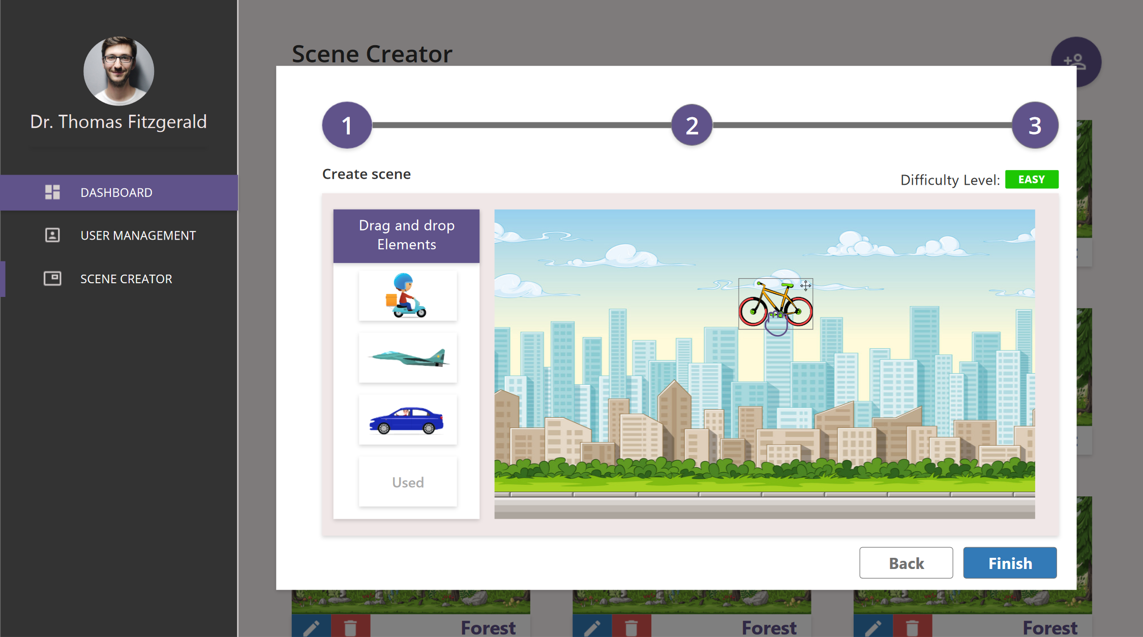

Figure 17: Editor Example [7]

Figure 17 shows an example of the editor, doctors can use to create the different scenes. Based on the UX/UI teams representation of the editor in the doctores interfaces, an unlimited amount of different scenes with varying complexities could be created. This allows the therapist to individually adapt the game process to the specific child.

## 11. Executive Summary

**Project Description:**

In order to boost the sales of the cochlear implants, the company “Heidelberg Hearing” asked SRH Heidelberg to come up with a concept for the application- Digital Hearing Assistant, supporting the affected children, improve their hearing ability. As part of this project, the Gamification & Education team is responsible for providing the concept for a game with increasing level of difficulty, as relying on the idea to apply game-based learning to improve the learning curve and increase the motivation of the user to learn new sounds with the help of the application.

**Target State:**

The target state of the project is to have an application for tablet in the form of a game, that allows them to improve their hearing ability. This game should be easy to interact with and nothing in writing, so that the child has no problem in understanding how to use the application. Additionally, there should be a motivational aspect that keeps the child engaged and motivated to keep using the application. A mascot should lead the child through the application, which makes the game self-explanatory. Out of this game, some data should be collected, which allows doctors to adapt difficulty to each individual.

**Project Lifetime:**

The project lifetime is set to 6 months.

**Target Group:**

The target group is children aged between 4-6 years with newly fixated cochlear implants that need to regain/ improve their hearing ability.

**Risk:**

The main risk is that the child won’t understand the working of the application and hence not know what to do.

**Opportunities:**

An important opportunity is that there are collaborative tie-ups with hospitals, clinics and other medical professionals.

## 12. References

1. **Gamification: Toward a Definition**: Sebastian Deterding, Dan Dixon, Rilla Khaled, Lennart E. Nacke. 2011. May 7–12, 2011, Vancouver, BC, Canada (page 2)

Source: <http://hci.usask.ca/uploads/219-02-Deterding,-Khaled,-Nacke,-Dixon.pdf>

1. **Hearing tests for children:** NHS. June 19, 2018.

Source: <https://www.nhs.uk/conditions/hearing-tests-children/>

1. McLaughlin, B., Pollice, G., West, D. (2006). **Head First Object Oriented Analysis and Design**, O’Reilly Media, Inc
2. **10 Reasons to Use Godot Engine for Developing your Next Game:** Ian Buckley. April 25, 2019

Source: <https://www.makeuseof.com/tag/reasons-godot-engine-game-development/>

1. **Godot Features:** 2007-2019 Juan Linietsky, Ariel Manzur, et al

Source: <https://godotengine.org/features>

7. **Editor Example:** UX/UI group at SRH Heidelberg Germany. May 3, 2018.

8. **S.W.O.T** analysis of gamification with challenges.

Source: <https://www.academia.edu/16903310/A_SWOT_Analysis_of_the_Gamification_Practices_Challenges_Open_Issues_and_Future_Perspectives>

9. **Risk analysis and management a vital key to effective project management:**Lavanya N, Malarvhizi T,(2008). Risk analysis and management: a vital key to effective project management. Paper presented at PMI® Global Congress 2008—Asia Pacific, Sydney, New South Wales, Australia. Newtown Square, PA: Project Management Institute.

<https://www.pmi.org/learning/library/risk-analysis-project-management-7070>